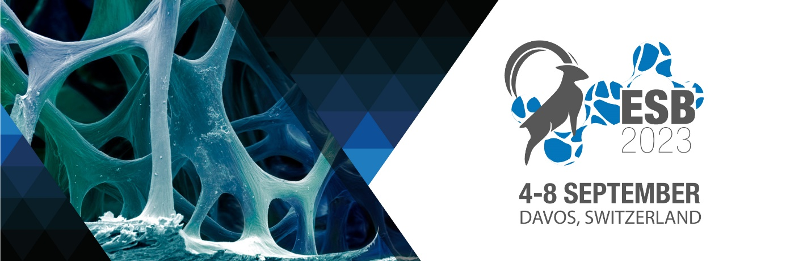

ESB Newsletter Oct 21, 2022 - 33rd Annual Conference of the European Society for Biomaterials

Dear Colleagues,

It is our pleasure to invite you to the 33rd Annual Conference of the European Society for Biomaterials, which will take place from September 4 to 8, 2023 in Davos, Switzerland.

We are glad to inform you that the Call for Symposia for ESB2023 is now open! Symposia provide a forum for focused discussions on new and emerging topics or innovative applications of established approaches. A symposium may revolve around a specific theme, or it may highlight the work done by societies or international consortia. Proposals must be submitted until December 15th, 2022.

Davos is a renowned village in Eastern Switzerland. Given the altitude and its geographical location in the Alps, the air quality in Davos is excellent, making the village during the last century the home to several famous clinics. Today, Davos is a beloved ski resort in winter and home to numerous other mountain activities in summer. Nightlife is also very active, with several pubs and bars where you can spend long convivial nights. Davos is also home to prominent conferences and events such as the annual AO Davos Courses, delivering best in class training for orthopedic surgeons, and the World Economic Forum, where the future of our planet is shaped. Therefore, Davos delivers an interesting mixture of urban flavor surrounded by glorious nature.

The Conference Team is looking forward to welcoming you to Davos!

For more information or any further questions: esb.davos@aofoundation.org.

Kind regards,

On behalf of the Conference Team

Matteo D'Este, David Eglin, Marcy Zenobi-Wong

